November/December 2016 PTA Newsletter
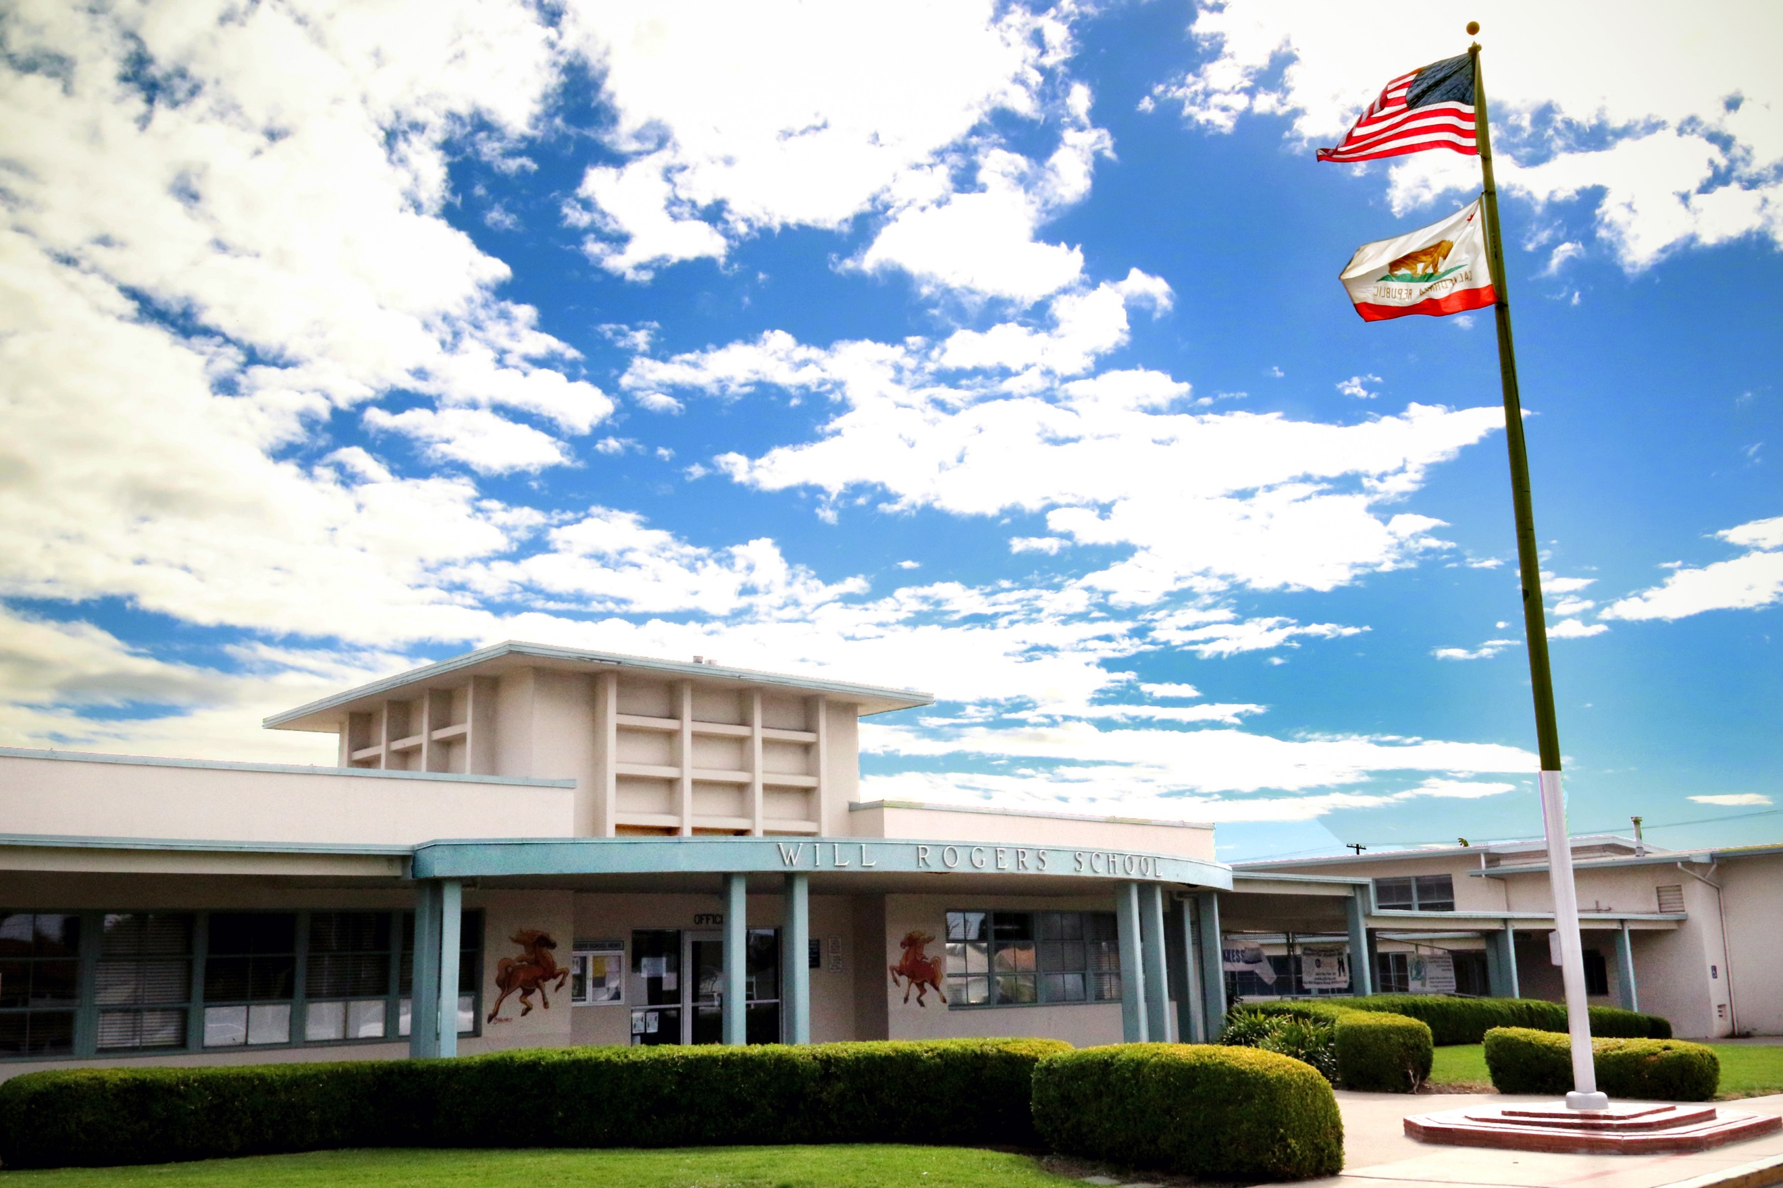

Upcoming Events

November 15

PTA General Meeting at 6:30

November 26

C-St Beach Clean Up (by pier) 9-11am

December 1

Restaurant Night at Urbane Café 4-9

December 1

Barnes and Noble Night 5:30-8:30

December 1

K-2 Music Performance at Barnes and Noble at 6:15

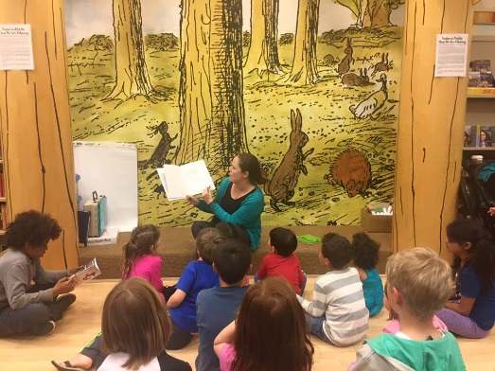

Dr. Cortes reading to students at the 2015 Barnes and Noble event!
K-2 Music Class Performance at Barnes and Noble Fundraising Event! Be there!

https://www.facebook.com/groups/WillRogersElementaryPTA
The PTA is holding a General Meeting on November 15 at 6:30 pm!!! There will be childcare and translation available. In addition to discussing important PTA events (like Carnival!) Dr. Cortes will give an overview on the school’s science curriculum and bullying prevention.

After School Programs – CODE.org

Your child was recently sent home a flyer about upcoming after school coding courses at Will Rogers. One teacher for CODE.org is paid for by the PTA with funds raised during the Jog-a-thon! The courses have shown to be very popular, and the PTA is happy to support students in learning this valuable skill. All children are encouraged to apply. Children who have not participated in these programs in the past will be prioritized. If your child is selected from the lottery, please ensure that he or she attends all five classes. Tuesdays, Nov 15, 22, and 29. Tuesdays Dec 6 and 13. There will be additional classes offered in the spring.

WR Family Night Out! December 1st - Mark Your Calendar!
Exciting things are happening in December at Will Rogers! Please join us at Urbane Café from 4-9pm for dinner. 20% of the proceeds will go towards our school when you show your flyer. Please “Follow” or “Like” Urbane Café on Facebook and Instagram to stay notified of this event!
After dinner, come on over to Barnes and Noble for our annual fundraising event. Our event starts at 5:30 – Will Rogers will host story time, a Lego workshop, bookmark crafting, and an art show. Get some holiday shopping done while helping out our school, and get them wrapped by our Will Rogers volunteers! Will Rogers receives 15% of all purchases made in store.
While you are at Barnes and Noble, please support our K-2 classes during their music performance! Ms. Manninen will be showcasing the musical talents of our young students starting at 6:15. Come cheer our young performers on!

C St. Beach Clean Up Day
November 26 – C. St/Surfer’s Point, 9-11am We’ve teamed up with Surfrider Foundation for a volunteer opportunity to clean up our beaches! All volunteers must sign a liability waiver (see WR website) and anyone under 18 needs adult supervision. RSVP required - please email Julie at jsalomonson@yahoo.com or (818)437-1847.
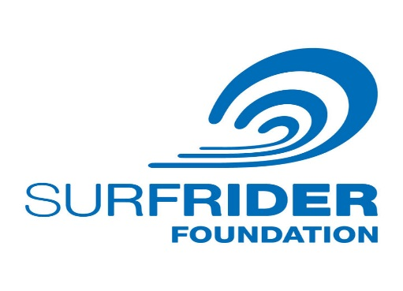

School Spirit Apparel
We have hats! Fill out an order form in the front office for your new, adult sized, Will Rogers Trucker’s Hat- only $10!!! We also have shirts and sweatshirts in children and adult sizes.

Jog -a-Thon Results are In!
We met and exceeded our goal of $25,000 by bringing in over $26,000! Thank you to everyone who helped their kiddos bring in those pledges. Another BIG thank you to all the parents who showed up to cheer on the students, keep them cool, run a station, etc. Envelopes with prize coupons are going home the week of Nov 14. If there is an error in the prize coupons your child earned, please email/call/text Rebeca at willrogersptaprez@gmail.com/901-6433. (And everyone, thank Rebeca for her hard work if you see her!)
Please thank the following business for donating services and certificates: Pump it Up, Vita Art Center, Got Rhythm Dance Studio, Delano Gymnastics, A-Frame Surf Shop, Billy Clower Dance Studio, Skating Plus, Sky Zone, Lazy Dog, California Pizza Kitchen, Presto Pasta, Subway, Jersey Mike's, and Sharky's.
WE DID IT!!!!

Box Tops for Education
Our PTA will be collecting Box Tops. These can be found on hundreds of name brand grocery items. Box Tops are a tremendous help to our school and classrooms. Please collect Box Tops and send them to school with your child. Don't forget to ask your friends and family to collect Box Tops for you. A collection sheet will be sent home with your child. Prizes will be given for most Box Tops collected by and individual student and a classroom party will be provided for the classroom that brings in the most Box Tops!!

PTA is Looking for a New Treasurer – Could That Be You?
The PTA is in need of a Treasurer for the 2017-18 school year. We would love to identify someone soon so that he or she can shadow the current Treasurer, April. The treasurer is an elected officer and the authorized custodian of all funds of the Will Rogers PTA. Some responsibilities of the office are keeping financial records, preparing reports, paying bills, and attending board meetings. Anyone with accounting or bookkeeping experience, or who is just a very organized person, would be great in this role! Bonus: This is a great way to beef up your resume!
Ongoing campus events: Book Exchange 1st and 3rd Friday of the month, Buy your Will Rogers gear in the office, and Volunteer in your child’s classroom!

